Curriculum Vitae (CV)

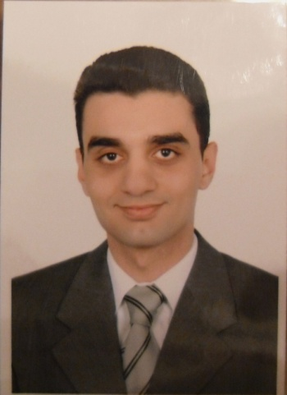

**Hesham Elsayed Mohamed Ibrahim Aboloyoun**

Assistant lecturer of Vascular Surgery,

Assiut University Hospital,

Assiut , Egypt

**Personal data:**

**First name**: Hesham

**Middle name**: Elsayed Mohamed

**Last name**: Aboloyoun

**Te**l: Home: +20882344490

Hospital:+20882413779

Mobile: +20121657612

**E-mail:** h_aboloyoun@yahoo.com

**Date of birth**: 1 May 1981.

**Place of birth:** United States of America (PA-Philadelphia)

**Marital status**: Single.

**Nationality:** Egyptian.

**Address**: Egypt, Assiut, 150 Nile st.

**Correspondence**: Egypt, Assiut, Assiut University Hospital, Department of Vascular Surgery.

**Languages**: Arabic and English

**Current position**:

Assistant lecturer of vascular surgery (since July 2009 till now ).

**Positions held**:

* House officer in Assiut university hospital (1 Mar 2005 to 28 Feb 2006)
* Resident in Department of Vascular surgery (Mar 2006 to July 2009)

**Qualifications:**

* High school diploma Dar Heraa School 1998
* MB.BCh: Faculty of Medicine, Assiut University 2004 (Excellent with honor degree).[1]
* M.Sc. In General surgery: Assiut University Hospital. [2]

**Professional licensure**: Egyptian Ministry of Health full registration no:172683

**Clinical Experience:[3]**

* *Diabetic foot*:

Care of diabetic foot,

Minor debridements

Toes amputations

Transmetatarsal amputation

Syme’s amputation

Below and Above knee amputation.

Disarticulation of hip joint.

Below and Above elbow amputation.

* *Venous diseases:*

Diagnosis and management of venous insufficiency

Diagnosis and management of DVT

Diagnosis and management of venous ulcers

Stripping of great saphenous vein

Foam therapy for varicose veins

Assistant in Valvuloplasty operations.

* *Chronic ischemia:*

Diagnosis and treatment of chronic ischemia

Fem-fem bypass

Fem-distal bypass

Fem-fem bypass

Axillo femoral bypass

Assistant in ilio femoral bypass

Assistant in profundoplasty

* *Acute ischemia:*

Femoral , popliteal and Brachial Embolectomy

Intra-arterial thrombolysis

* *Dialysis access:*

Radiocephalic AVF

Brachiocephalic AVF

Transposition of Basilic vein AVF

ePTFE graft fistula of upper and lower limbs

* *Endovascular intervention:*

Dilatation and stenting of SFA

Assistant in tibial vessels dilatation

Assistant in iliac artery dilatation and stenting

* *Aortic surgery*

Assistant in exclusion of AAA

Assistant in Aorto-bifemoral bypass

* *Trauma:*

Repair of peripheral arterial injuries including Femoral, Popliteal, Brachial, Axillary vessels

Assistant in carotid artery repair

Assistant in IVC repair

* *Carotid surgery:*

Assistant in carotid endartrectomy.

* *Others:*

Lumbar sympathectomy

Assistant in trans thoracic sympathectomy

Assistant in cervical rib resection.

**Teaching activities:**

* Supervising House Officers since March 2006
* Senior Resident supervisor since March 2008
* Undergraduate teaching of the final year medical students since March 2009

**Graduate courses, postgraduate trainings and conferences attended:**

* 1998-2004: Graduate studies, Faculty of medicine, Assiut University
* 2005-2006: House officer, Assiut University Hospital.
* 2006-2009: Resident in Vascular Surgery Department.
* 2005-2010: Attended the annual conference of Assiut faculty of medicine.
* 2009: six months training in General Surgery Department

**References and confirmation:**

**[1]** Assiut University was inaugurated in 1957 to encourage research, education and community services in Upper Egypt. It is located in Assiut City which is 375 Km south of Cairo, the capital,. The University comprises sixteen faculties and two higher institutions. PO Code N; 71515, Egypt. <http://www.aun.edu.eg>

**[2]** Assiut University Hospital is one of the largest University Hospitals in Egypt. It is the core referral center for the whole Upper Egypt that serves about 20 million people. <http://www.aun.edu.eg/fac_med/medicin/hospital2.htm>

**[3]**  Professor Dr. Hassan Bakr Al-Badawy; Professor and founder of the Department of

Vascular Surgery in Assiut University Hospital.